

LA GRANDEE INTERNATIONAL COLLEGE
Simalchaur, Pokhara, Nepal

A Project Proposal
On
“Study-Buddy”

Submitted To
LA GRANDEE International College
Bachelor of Computer Application (BCA) program
In partial fulfillment of the requirements for the degree of BCA under
Pokhara University.

Submitted By
Full Name: | Program/Semester: | PU Registration:
Depika Kumari Sharma | BCA/4th | 2024-1-53-0164
Prasid Gautam | BCA/4th | 2024-1-53-0174
Sampada Pahari | BCA/4th | 2024-1-53-0184

Date: 6th May 2026
Table Of Contents
1. Introduction: 3
2. Problem Statement: 5
3. Objectives: 6
4. Background Study: 7
5. Methodology: 8
5. Gantt Chart: 9
6. Requirement Document: 10
6.1 Functional Requirements 10
6.2 Non-Functional Requirements 11
7. System design 13
7. Deliverables: 15

List Of Figures
4. Agile Model…............................................................................................................4
5. Gantt Chart..................................................................................................................5

1. Introduction:
In an increasingly digital learning environment, students often struggle to find reliable academic resources such as lecture notes, past examination papers, assignments, and study materials. While many students rely on informal platforms like messaging groups and social media for sharing resources, these methods are often unorganized and inefficient. Study-Buddy is a desktop-based application designed to solve this problem by providing a structured platform where students can share, search, and request academic resources easily. A major feature of the system is the Request Board, which allows students to post specific resource requests so that other users can contribute and help them access the required materials.
The system is developed using Java for application logic and user interface development, while Microsoft SQL Server (MS SQL) is used for database management and storage of user and resource information. The application aims to promote collaborative learning among students by creating a secure, organized, and user-friendly environment for academic resource sharing.

2. Problem Statement:
Although several platforms and informal channels are available for sharing academic resources, they still have many limitations that reduce their effectiveness for students.
- Limited Accessibility:
Many educational resource platforms provide restricted access to study materials and require subscriptions or special permissions, making it difficult for all students to access necessary academic resources equally.
- Unorganized Resource Sharing:
Students often depend on messaging groups, social media platforms, or shared drives for exchanging study materials. These platforms lack proper organization, categorization, and efficient search functionality, making resource management difficult.
- Lack of Centralized Platform:
There is no dedicated and centralized desktop-based system where students can easily upload, search, request, and manage academic resources in an organized manner.
- Difficulty in Requesting Specific Resources:
Most existing systems mainly focus on sharing materials and do not provide a proper mechanism for students to request specific notes, assignments, or past examination papers when needed.
- Poor Resource Management:
Many existing sharing methods do not maintain proper records, categories, or user management features, which leads to inefficient searching, duplicate resources, and difficulty in maintaining resource quality and security.

3. Objectives:
The primary goal is to develop a functional, user-friendly software application that meets the following specific objectives:
- To develop a structured platform for sharing and accessing study materials easily.
- To improve data reliability through user verification and rating system.
- To allow students to request and provide specific academic content.
- To make learning resources easily searchable and well-organized.

4. Background Study:
There are several platforms and tools that loosely address the needs of students seeking academic resources:
Existing Systems
Platform | Key Features | Notes
Course Hero | Upload/download notes, Q&A help | Subscription-based, limited free access
Chegg | Study guides, answers | Paid, focus on textbook solutions
One Class | Student notes repository | Free & paid options, curated notes
Google Drive / Discord Groups | File sharing & community chat | Not tailored or structured for academic resource exchange
Reddit (r/College & r/Notes) | Crowdsourced sharing | Unstructured, hard to moderate

Observations
- Most platforms are either commercial (locked behind paywalls)
- Many lack structured search or incentive systems
- Informal channels have no metadata, search, or categorization

Methodology:
The project we will be designed according to the format prescribed by the college. The required data will be collected from some reference, related sources and some from internet. Agile model will be used as the program development process.

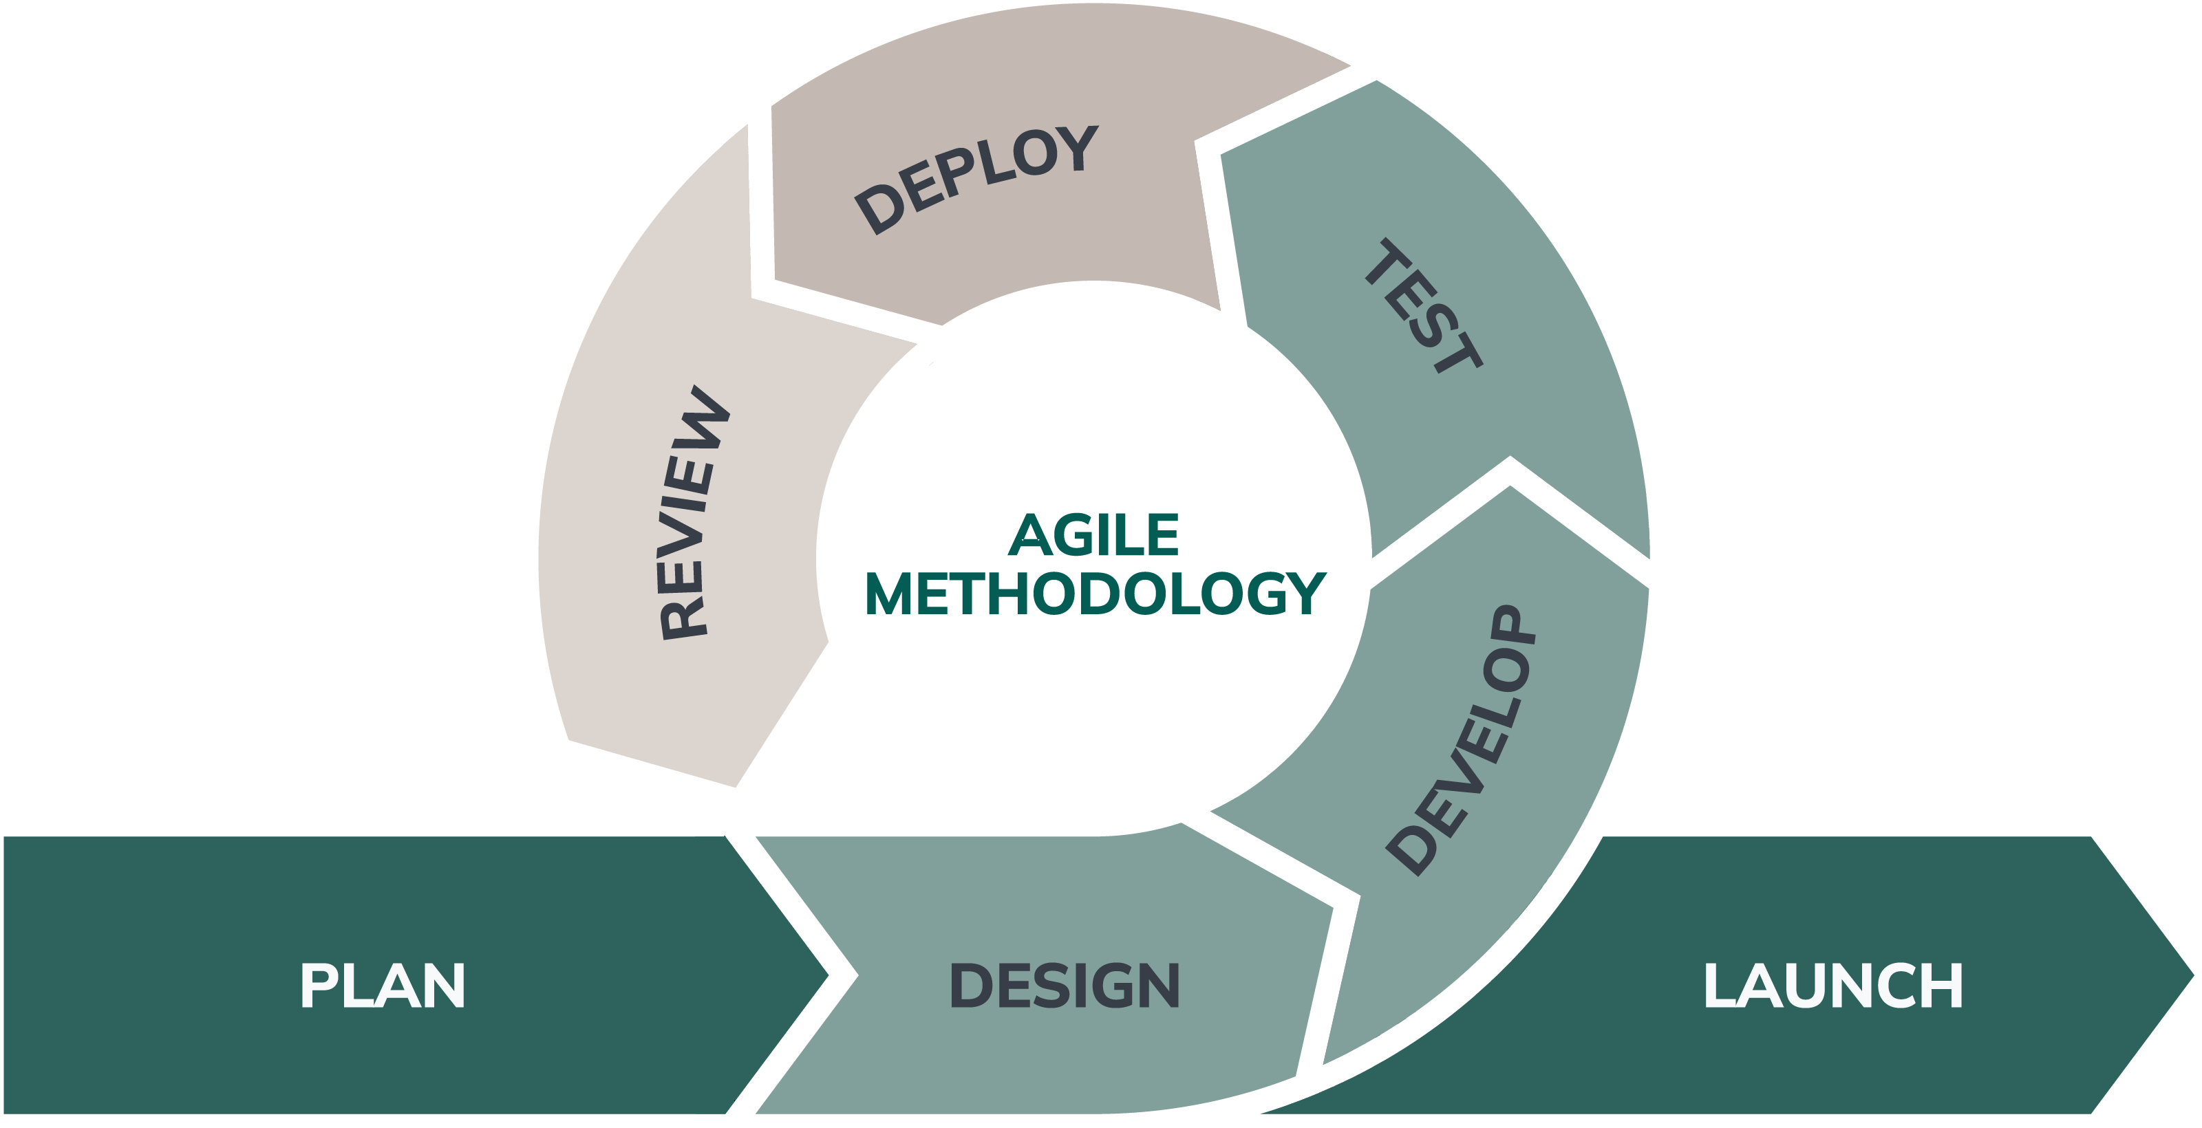

Figure 1: Agile Model

5. Gantt Chart:

Figure 2: Gantt Chart

6. Requirement Document:

6.1 Functional Requirements
1. User Authentication & Profiles
- Register users with email and password
- Login users securely into the system
- Create and manage user profiles (name, course, details)
- Store passwords in encrypted form
2. Upload & Resource Management
- Upload study materials (notes, assignments, past papers)
- Add subject, course, and keyword details
- Search and download resources
- Preview available materials
3. Request Board
- Post requests for specific study materials
- Add subject and description in requests
- Respond to requests by uploading resources
- Update request status (Open / Fulfilled)
4. Search & Filters
- Search resources using keywords or subjects
- Filter resources by category or type
- Sort results for easy access
5. Resource Interaction
- View and download study materials
- Rate or give feedback on resources
- Identify useful content through ratings.
6. Admin Management
- Manage users and uploaded content
- Remove invalid or duplicate resources
- Monitor system activities

6.2 Non-Functional Requirements
1. Performance
- Ensure fast search and response time
- Support smooth system operation
2. Security
- Secure user login system
- Protect data using password encryption
- Restrict access based on user roles
3. Usability
- Design simple and user-friendly interface
- Provide easy navigation for all features
4. Reliability
- Maintain accurate and consistent data
- Store data securely in MS SQL database
5. Maintainability
- Develop modular and well-structured code
- Allow easy updates and modifications

7. System design
System design is the process of defining the architecture, components, interfaces, and data of a system to satisfy user requirements. It helps in developing an organized, efficient, and scalable solution for the proposed Study-Buddy system.
7.1. Feasibility study:
A feasibility study evaluates whether the proposed system is practical and achievable by analyzing technical, financial, market, and operational aspects.
1. Technical Feasibility
- The system is technically feasible using Java (Swing/JavaFX) and MS SQL Server.
- Supports features like login, resource sharing, and request board.
- Required skills and tools are available.
2. Financial Feasibility
- Minimal cost required
- Uses free or open-source tools and technologies
- No major hardware or software expenses.
- Suitable for student-level development.
3. Market Feasibility
- Provides a centralized system for study materials.
- Students need a structured platform to share and request study materials
- Solves problems of existing platforms: poor organization and limited accessibility
4. Operational Feasibility
- Easy to use, maintain, and manage
- Features: searching, uploading, requesting resources
- Improves user experience and system efficiency

Conclusion
- Study Buddy is practical, achievable, and beneficial for students.
- Can be completed within the available time and resources.
- Effectively supports collaborative learning and resource sharing.

7. Deliverables:
When we develop a program, we face many problems and we try to overcome the problems by maintaining the features of it properly but the system can’t perfect, there may be some problems but after developing the program we always except a better output. Deliverable refers to the specific, measurable output or results the project aims to produce and deliver. The expected output is;
- Source code written in Java.
- Documentation of the code and any design decisions made during developments.
- A README file with instructions on how to compile and run the program.
A complete program that implements as described.

